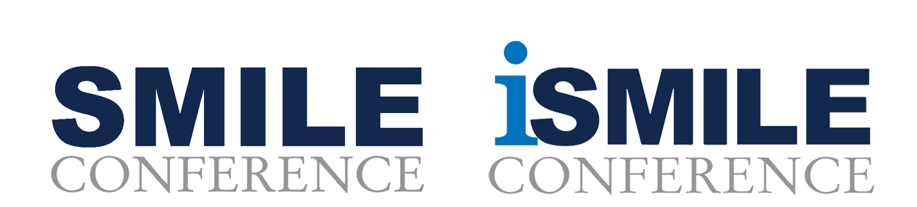

[Insert Date]

Dear Chief,

I am writing to request authorization to attend the SMILE/iSMILE conference in Palm Beach Gardens, FL, scheduled for September 16th-19th, 2024. This conference offers a unique opportunity for professional development, particularly in enhancing my proficiency in leveraging social media effectively.

The SMILE Conference stands as a pinnacle in providing law enforcement personnel with comprehensive training in utilizing social media for community engagement, event coordination, and investigative purposes. With its rich history spanning 19 editions, this year's SMILEcon promises five days of immersive learning experiences. Additionally, the iSMILE segment, dedicated exclusively to investigative techniques, will feature two days of specialized content.

Of particular interest are the breakout sessions, notably COSmile, focusing on community outreach strategies through social media platforms.

I am seeking approval to attend the following option(s):

___ 3-day SMILE Conference – Sept 16-18
___ 2-day iSMILE Conference – Sept 18-19
___ 5-day SMILE and iSMILE – Sept 16-19

The caliber of instructors and presenters at the conference is renowned for being unparalleled, offering insights into various facets of social media utilization in law enforcement. By participating in this event, I aim to acquire valuable knowledge and skills that will directly contribute to our agency's social media strategies and initiatives.

Moreover, attending the SMILE/iSMILE conference will afford me the opportunity to network with esteemed professionals from across the globe, facilitating the exchange of best practices and fostering potential collaborations. Upon my return, I am committed to disseminating the acquired knowledge amongst my colleagues, ensuring that our department remains at the forefront of social media utilization in policing.

Considering the registration costs outlined below, I am mindful of the budgetary implications and assure you that my attendance will be a prudent investment in advancing our department's capabilities in social media engagement.

Registration cost summary:
CONFERENCE | Now - August 31st | Sept. 1st – Sept. 16th
SMILE | $599 | $749
iSMILE | $499 | $649
SMILE & iSMILE | $999 | $1,149

I am confident that participating in the SMILE/iSMILE conference will yield significant benefits for our agency, and I respectfully request your approval to attend this event.

Thank you for considering my request.

Sincerely,

[Your Name]

